Case study Whack-a-mole

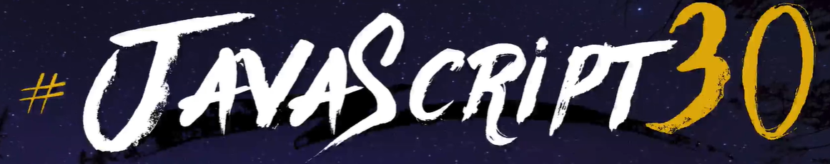

*Overview*

At our course here at SmartStudy we were to make a Whack-a-mole following the 30-day JavaScript30-challenge. We did not actually do 30 days of coding, but jumped straight to the last day, which was the Whack-a-mole game.

The setup is that we watch a video when a guy makes the game, then we code alongside the 14-minute-long video.

I made the game work and I’m happy with that.

*Context and challenge*

1. Project background and description

This was another game we were asked to make, on top of the others we made. It is a good way to learn JavaScript.

1. Problem/why

To better our developing skills.

1. Project-goal and objectives

Make a functional Whack-a-mole game.

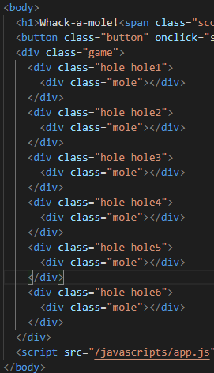*Process and insight*

This was a solo task. Everyone in class sat down and did their work at their own pace.

*The Solution*

I typed along the video, looked after to write it correctly to make it work.

*The Result*

The tutorial was very insightful and good explained. The game works perfectly. It is a bit hard, but I like the challenge.

